Final Exam

Last Name: Shanks

First Name: Cole

UBC Student #: 54950860

Supporting Calculations

Analysis

I created a basic Net Present Worth Analysis based on the information given to analyze these options. The benefit of Option B is clearly the 2% rebate. Therefore, if you spend a lot on Gasoline and Grocery purchases then Option B is likely the better option. Conversely, if you spend very little on Gasoline and Groceries then you are better off sticking with A. However, there is other information that would be useful to know. Option A involves a large bank whereas Option B involves a local bank and you would want to make sure the local bank is reputable and doesn’t have solvency issues or anything that would lead you to believe your money was at risk. You would also want to know the inflation rates for prices to get a more accurate picture of the situation. Ultimately, your gross spending on Gasoline and Groceries is the most relevant information you would want to know based on the information given.

**We don’t know** how many years the machine should be used for before it is sold. We need more information.

Required Information:

* Marginal Cost data for the Defender
* Minimum EAUC of the Challenger

Given this information. We could then compare the EAUC of the Defender in each year with the Challenger’s minimum EAUC and determine how many years the machine should be used for.

YES, the project should be constructed.

* It should be constructed in the year 2021
* This gives a NPW of $530,373

Factors to Consider

* Costs of incorporating
* More detailed tax reporting each year associated with running a business. Also, any fees paid to accountants to shoulder this responsibility
* Issues of liability and how that changes from a proprietorship to a corporation

Additional Data

* Maintenance costs associated with each turbine on an annual basis
* Salvage values for each turbine when their useful life has expired
* Advances in technology in this sector and each turbine’s characteristics

Reasons

* The salary of Job Offer 1 begins higher but it surpassed by Job Offer 2 due to its higher salary increase per year
* It has a higher NPW given an equivalent discount rate and the cash flows over 10 years
* Better at “fighting” inflation and yielding real buying power in the marketplace that increases yearly

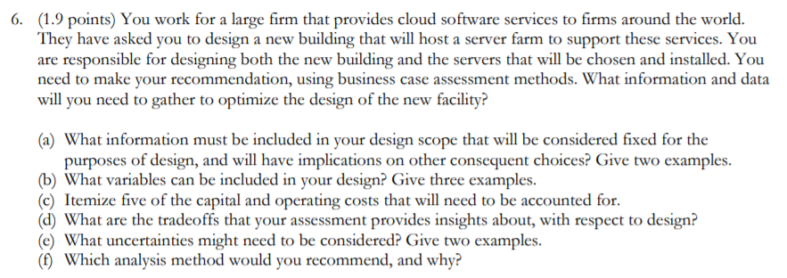

Objectives

* Design a new building to host a server farm that will support cloud-based services
* Select the servers that will be chosen and installed
* Use business case assessment methods to inform my decisions

(a)

Useful Life (Servers)

* The first thing that is important is to concretely define the useful life of our design. The building will likely have a very long useful life. This is the type of asset that it is. But the servers should be defined concretely so that we know when and where replacement will occur.

Technology

* The specific type of technology. For this kind of venture, the technology is moving very rapidly. Therefore, it is important to choose a design that can keep pace with the latest technological development

(b)

Variables

* Maintenance
* Engineering Drawings
* Shipping and delivery costs

(c)

Capital/Operating Cost

* DIRECT: Cost of Materials
* DIRECT: Cost of storing before delivery
* INDIRECT: Interest Payments
* INDIRECT: Machine Depreciation
* INDIRECT: Insurance Costs

(d)

Tradeoffs

There are various tradeoffs that should be considered with the delivery and implementation of a product. Among them are: Reliability, Performance, Useful life, Flexibility, etc

(e)

Uncertainties

* Breakdown of the machine
* Long-term functionality and performance

(f)

Analysis Method

* **Triple Bottom Line**. It’s the most comprehensive and fully engaged analysis method and would be suitable for this design

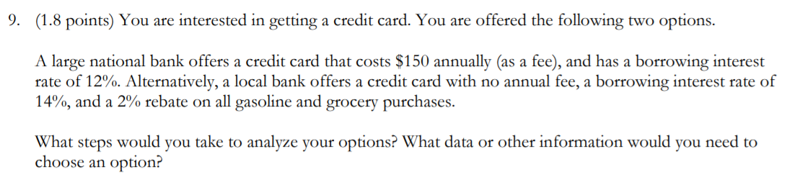

Option A (National Bank)

* PRO: It is a National Bank therefore I can have good assurances that my money is safe and secure. It is unlikely for a large accredited bank to fail (although not impossible)
* PRO: Low interest rate (Relative to Option B). This option has a lower interest rate associated with the credit card and that would yield cost savings over time
* CON: $150 annual fee. There is no fee associated with option B so this would be an additional yearly cost I would undertake if I went with this option

Option B (Local Bank)

* PRO: No annual fee associated with the card
* PRO: 2% rebate on Gas and Grocery purchases. If I spend a lot on Gas and Groceries than this would seem like a very good option that yields high savings. Conversely, If I spend little on Gas and Groceries than this rebate would not concern me
* CON: High interest rate (Relative to Option A). The interest rate for this option is slightly higher. For a credit card, this would cost more money over time

Steps to Analyze Options

* Weigh PROS and CONS of each
* Ensure this bank aligns with my long-term financial goals and objectives
* Make an informed financial decision and seek professional advice if necessary

Additional Data

* Consider other options available if present
* Consider the importance of an interest rate, fees, benefits, etc and weigh all of these based off of my own value that I put on each of them
* Calculate my Gas and Groceries spending and determine how useful this rebate is to me
* Consider any future loans I’m expecting to take on in the future for various projects



Option B (Rent) leaves you in a better financial condition. Ie: Option B costs less

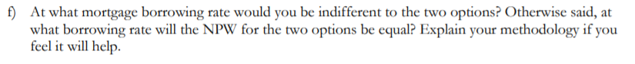

At a borrowing rate of 2.76%, I would be indifferent. At this rate the NPW of both options are equal. I solved by guess and check

Errors

* **CELL H8**: Half-year rule applies in the first year of CCA depreciation. The depreciation should be $7500 not $15000
* **CELL L66**: IRR formulas yields an error. Methodology was correct but should have noticed this error
* **CELL M9-Q9**: Error along this row. The sales should be increasing at a rate of 3%/year but instead it is the same year-year
* **CELL M14**: This is an incorrect value for the CCA depreciation
* **CELL L32**: The B/C Ratio is incorrect. It’s using incorrect values
* **ROW 62**: Discounted Net ATCF is Off from the first number
* **CELL M24**: Incorrect value carried from above
* **ROW 12**: Capital Asset Loan repayment scheme is incorrect
* **ROW 52**: Income tax is still being calculated in Option B even though taxable income is negative. No income tax should be payed in these columns. S,T,U,V
* **CELL V49**: Gain on disposal is being used to offset tax when the reverse should be applied
* **CELL L62**: NPW Calculation is missing values in its sum and is therefore producing a negative NPW that is incorrect
* **CELL P13**: Value is incorrect